Color code:
Text to be updated
Text as example
Text to be removed

User Requirement Specifications
<IT System Name>
<Project Code>
<Project Name>

After having typed the document title in “File → Properties” as described above, click on this field and press F9 to update it and make the title appear.
TABLE OF CONTENTS
1 Introduction 2
2 Descriptions 2
2.1 Project description 2
2.2 Glossary of Terms 2
2.3 Present situation 3
2.3.1 Description of the Current activity 3
2.3.2 Issues and Disconnects 3
2.4 Expected Benefits 3
2.4.1 Benefit Description 3
2.4.2 Scope 3
2.5 Methodology 4
2.5.1 Rating of requirements 4
2.5.2 Data flow 4
2.5.3 Charts 5
2.5.4 Requestors 5
2.6 User Requirements 5
2.6.1 High level process flow 5
2.6.2 Data requirements 5
2.6.3 Functional user requirements 7
2.6.4 Non-functional user requirements 8
2.6.5 System administration and operation 10
2.6.6 Service Level management 10
3 References 12
4 Version History 13
5 Signatures 13

Introduction
This template must be used applying the process described in the SOP ITPMA_3SOP_005 Requirement Management.

Usually these business requirements are quite high level, and bring the project rationale (the
why), as well as goals and tasks that the users must be able to perform.
For large project some of the sections may be outsourced to other separate documents.

Descriptions

Project description
This chapter should contain a brief description of the request:
- Brief description of the main objectives of the project
- Brief description of the activity to automate
- Brief description of the context
- Brief overview of the Function(s) involved in the project

Glossary of Terms
This chapter is to explain the specific terms used for the project.

Term | Definition | Reference or Remark

Present situation

Description of the Current activity
This is the Is Map of the processes.

Issues and Disconnects
This part is to lead the reader to understand why we have launched the project.
It explains what is wrong with the current processes.

Expected Benefits

Benefit Description
Describe the expected business benefits that the IT Solutions would bring to the organization.
These benefits have to be described such a way:
- To commit on benefits
- To agree between Business and IT metrics to confirm benefits realization
- To agree accountability on benefits realization
- To allow tracking and reporting of value realized and forecasted
- To allow post implementation reviews on performance
A review of benefits realization may be done with the Corporate Internal Audit.

Scope
The scope is:
- geographical (WW, HQ, A Site, A region, etc.)
- about the users (R&D, Manufacturing, Marketing & Sales, etc.)
- functional (which part of the processes is concerned)
- etc.

Methodology
Please describe the differing documentation methodology
This methodology chapter is to explain how the requirements are described.
The Project Team should use this methodology as a set of recommended advices but is free to write the requirements with another methodology as soon as it has been agreed with IT PMO and/or IT QA.
If another methodology has been chosen, please describe this methodology.

Rating of requirements
The requirements do not have the same importance. These ratings help to make priorities between the requirements and to decide about the acceptability of the system from a general “project” viewpoint. If GxP-relevant requirements exist their rating with regard to GxP regulations will be performed in a separate Risk Analysis, in the framework of the validation activities.
- Mandatory (MAND)
The requirement is mandatory.
The system will not go live without having this item being properly addressed and successfully tested.
- Critical (CRIT)
The requirement is critical.
A risk analysis will be performed and an action plan will be written if absent or if the future test fails. Issue with items having this severity level will not stop the system to go live.
- Important (IMP)
The requirement is important.
An action plan will be written if absent or if the future test fails. Issue with items having this severity level will not stop the system to go live.
- Nice To Have (NTH)
The requirement is nice to have.
The requirement can either be dismissed, postponed to a later version or re-phrased if absent or if the future test fails. Issue with items having this severity level will not stop the system to go live nor to close.

Data flow
The requirements should be sorted by functional domains. A data flow is mostly recommended before describing each domain. This helps to link the requirements in the system global understanding.

Charts
The charts contain the numbered requirements. They are recommended to structure the requirements and to perform the tests against the requirements.

Requestors
The requestor is the representative and responsible unit for each requirement. In case of question, this will help to find the right person and the right answer.
The requestor can be a group. In that case, the head of unit will represent the group.
The requestor can also be a legal or regulatory requirement. In that case, the head of unit will represent the group.

Example:
Requestor | Abbreviation | Representative Person
21CFR Part11 | CFR
WW Regulatory Affairs | WWRA
Law and Legal requirement | Legal
Manufacturing Packaging | Pkng
Manufacturing Warehouse | Whse
Manufacturing Fill & Finish | F&F

User Requirements

High level process flow
A general process flow is recommended to describe the overall project.
- 訂單來源：
  - 業務 (電話 / 傳真 / E-mail)
  - 客戶 (電話 / 傳真 / E-mail)
- 客戶訂單型態：
  - 有接到客戶正式數量訂單 / 紙本合約，有CPO
  - 出貨交期未確認，待客戶通知出貨
  - 訂單或合約有載明產品訂購數量 / 或訂單總金額
  - 訂單類型只能為Standard Order (S11 / ZMS2)
  - 退貨訂單：當期退貨 (Order Cancel R11) + 隔月退貨 (ZMR4 / R21)，但不含發票退改及退貨調整(不含Storage Location 2602的退貨)
- Schedule Agreement Log成立：
  - 在Front Screen新增一個”Schedule Agreement” Log功能(類似Quotation Log)，將此Schedule Agreement的資料只保存在Front Screen，不串聯到SAP
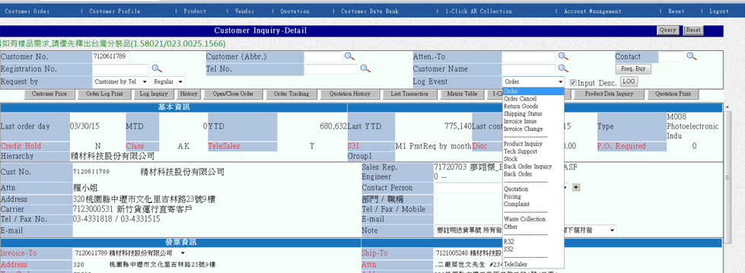
  - Schedule Agreement Log Head輸入資料要包含：
    - Schedule Agreement的Type ; Agreement Type可由下拉選單選擇數量管理或金額管理
    - 客戶編號 (Sold to)
    - 客戶運送地址 (Ship to)
    - CPO (Customer Purchase Order No.)
    - Schedule Delivery Date
    - Order Note Description
    - Valid From
    - Valid to
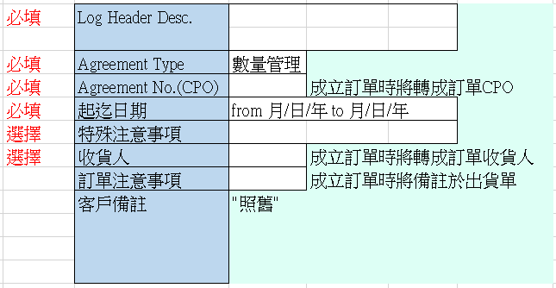

  - Schedule Agreement 詳細內容輸入資料要包含：
    - 產品編號
    - 產品數量
    - 產品未稅售價
    - 若為”金額管理”類型，可輸入一般產品料號/數量/金額，或輸入item#999999 替代之
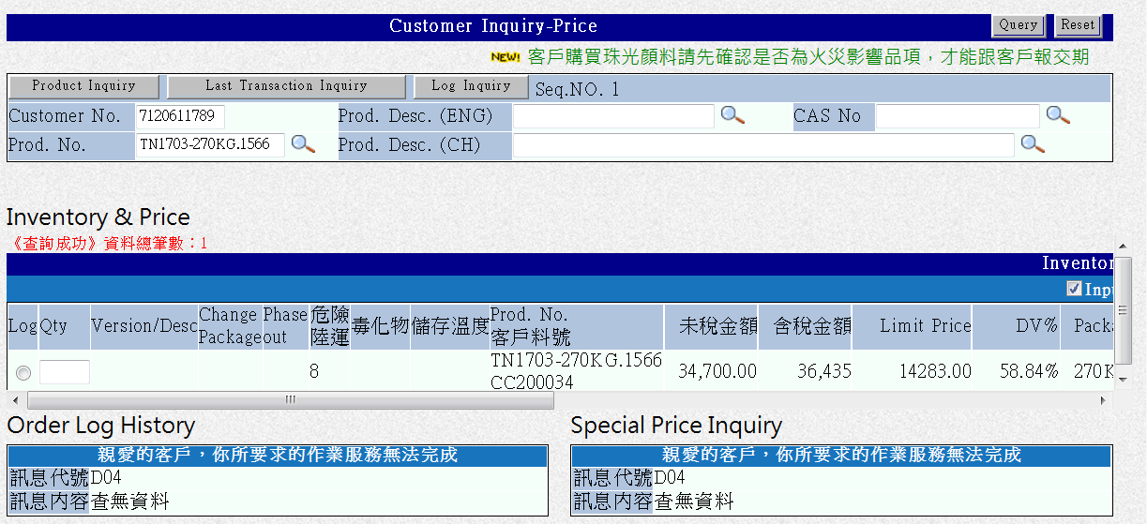

  - Schedule Agreement輸入完成儲存前：
3.4.1 若為”金額管理類型” ，須輸入未稅總金額
3.4.2 其他如現有Order Log ，可再次檢或更改Bill-to/Ship-to/…等必要項目
3.4.3 須夾附該Schedule Agreement PDF檔案方能儲存
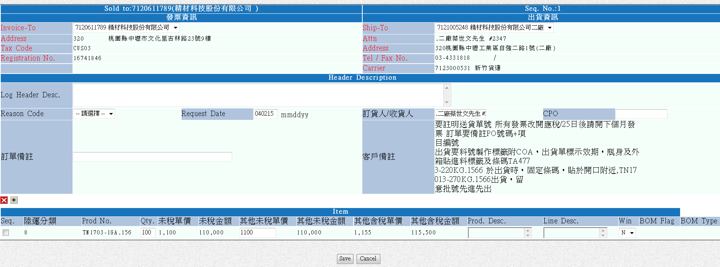

  - Schedule Agreement 中若有產品Price低於Limit，則循現有Order Price Block 核可模式後完成
  - Schedule Agreement 中若有產品屬毒化物，則循現有Quotation 警示
  - Schedule Agreement完成儲存後，可立即在Customer Detail查詢到
3-7-1 Hierarchy 欄位右側加入另一欄位 "S. Agreement"(紅字)
3-7-2 當Customer No.下有任何open的Schedule Agreement,則顯示Y(紅字)
3-7-3 所有Hierarchy 名稱等於此Customer No.的其他Sold-to的同一欄位也顯示Y(紅字)
3-7-4 不符合2&3的，則顯示"N"(黑字)
3-7-5 若為 “金額管理”類型，Schedule Agreement 的剩餘金額小於/等於時，則顯示"N"(黑字)
3-7-6若為 “數量管理”類型，Schedule Agreement 的所有ITEM數量小於/等於時，則顯示"N"(黑字)
3-7-7 點選Schedule Agreement 欄位中的 Y時,連結至查詢畫面 (ref. to 6.1)
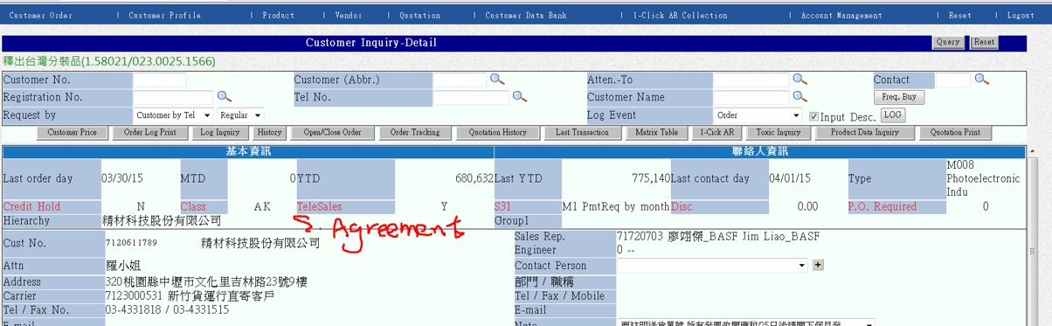
  - Log成立後，利用Front Screen的Order Log Print功能可以查詢的Log的記錄
    - 在Schedule Agreement 第一次轉出貨前，原Log者，可見修改符號並進入修改
    - 第一次轉出訂單後即不能由Order Log Print入口進入修改
- Schedule Agreement 內容查詢
  - 加入原有Quotation Print 中查詢；Log Event 下拉可選Quotation或
  - 顯示Schedule Agreement 成立內容，包括原Quotation Print內容Schedule Agreement
  - 並加入Schedule Agreement Type，起迄時間，Schedule Agreement未稅總額，CPO#
  - 可用CPO# ，不限日期查詢 （類似Seq No.查估價單）
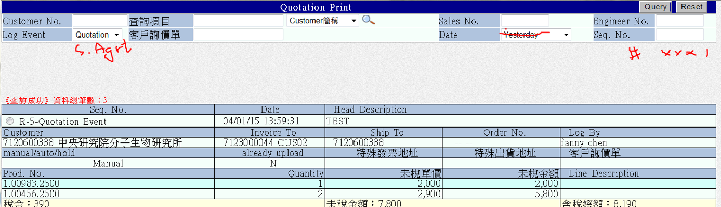
- 利用Schedule Agreement 轉Order(或Back Order)
  - 在現有Quotation Print 中查出Schedule Agreement
  - 同Quotation轉Order 功能
    - User 可挑選Item，數量管理類別的需再加入餘量值，出貨數量值空白如Loger填寫；更改數量時，價格應維持原Schedule Agreement 價格
餘量 | 本次訂購量
20 | (空白)

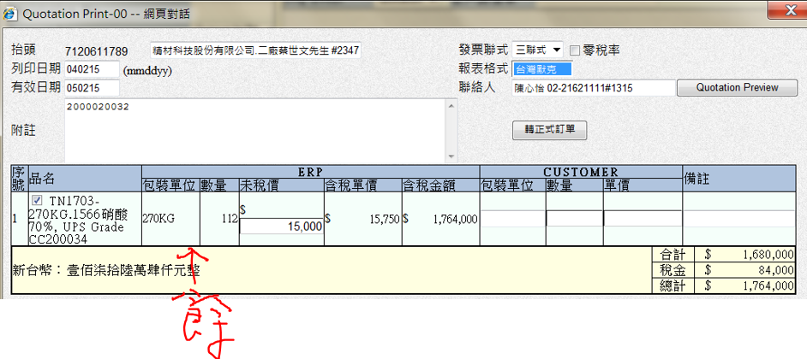
    - 可在最後儲存前修改金額，但需秀 "Warning message 告知"售價不符原Agreement";確認修改後需填入原因

    - 若為＂數量管理＂類型，不可增減項目；各項目數量超過餘量時，訂單不予成立
    - 若為＂金額管理＂類型，可任意增減項目；總金額超過剩餘金額時，訂單不予成立
    - 若為＂金額管理＂類型，ITEM#999999 不帶入Order ，由User自行加入ITEM
    - 為＂數量管理＂類型，可加入增加替代料號對照表
      - 如產品A可由B+C代替，可針對A，加入"替代料對照表"
      - 出貨時如檢查替代對照表為有效期間，則不帶入產品A，直接帶入替代對照
      - 起訖時間請預設今日
原料號 | 數量 | 金額 | 替代料號 | 替代料號數量 | 替代料金額 | 替代原因 | 起迄時間
A | 1 | 1000 | B | 1 | 500 | 缺貨
 |  |  | C | 1 | 500 | 缺貨

- 新增Schedule Agreement Inquiry
  - “數量管理”與”金額管理”各顯示以下內容
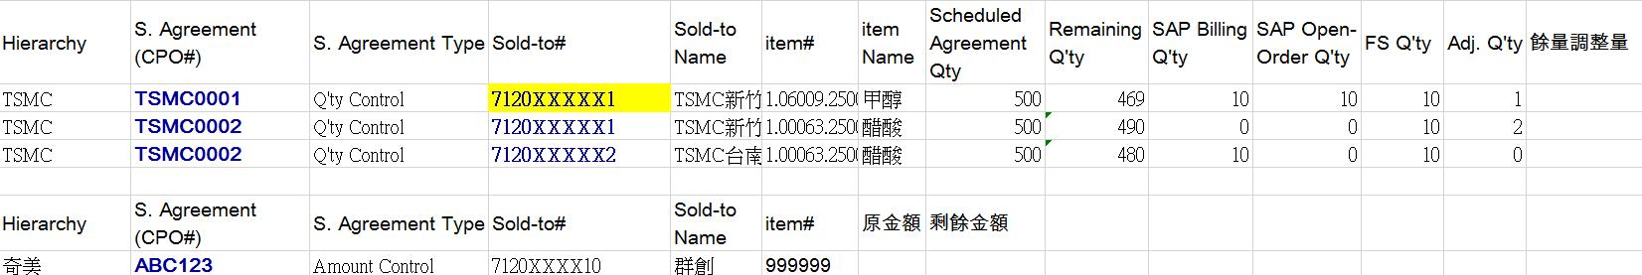
  - 點選CPO 可連結至轉訂單功能
  - 點選 Sold-to # 可連結至該客編下的Open/Close Order
  - 查詢頁面下，提供管理者做餘量調整
6.4.1管理者權限，可對"數量管理的Schedule Agreement" 做剩餘量的調整，調整須記錄原因,時間,與調整者
6.4.2 餘量調整只計算在Schedule Agreement各產品剩餘量(ref to 6.1)，不複寫更改原Schedule Agreement數量(ref. to 4.4)
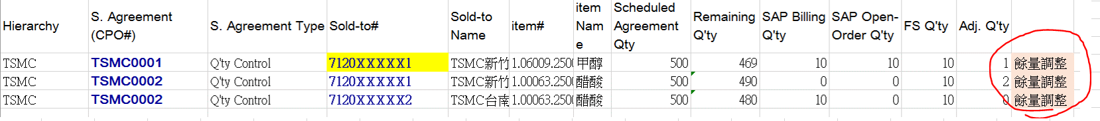
- 從"Quotation Print" 的 Quotation or S. Agreement 轉成另一張Schedule. Agreement
7.1不 COPY原CPO
7.2 接續至3.2
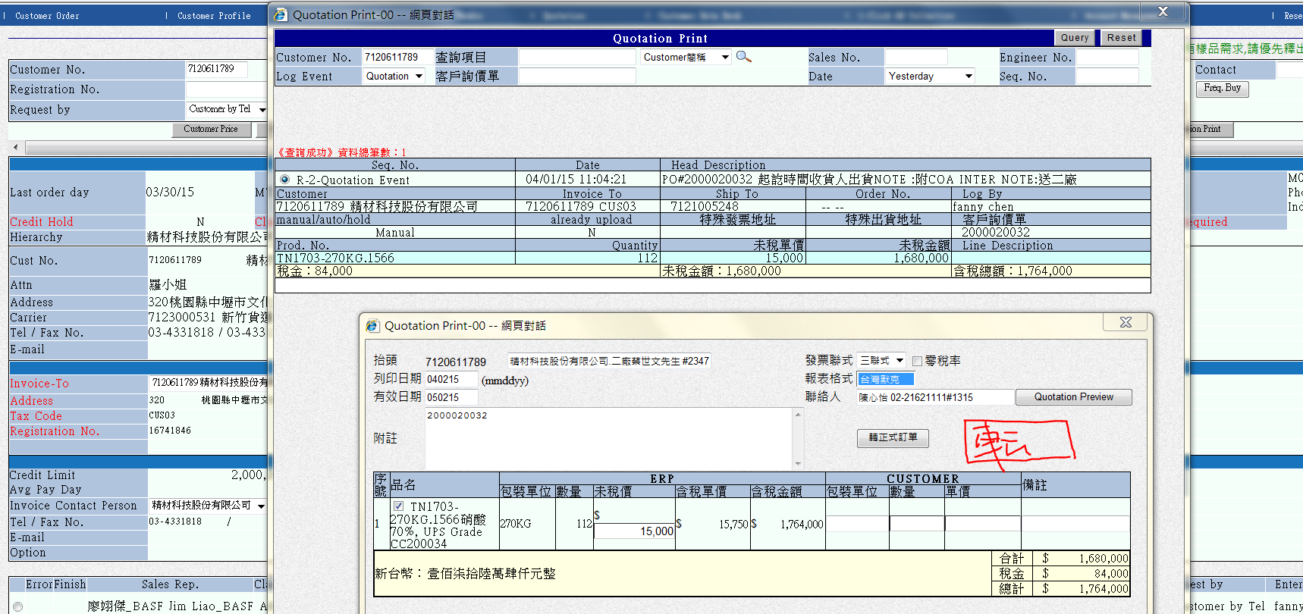

Data requirements

Data description
This section describes the data involved in the project
# | Information | Format | Valid Values | Source
 | Field 1, ex : Code | Ex: N10 |  | Automatic
 | Field 2, ex: Description | Ex: A30 |  | Input
 | Field 3, ex: Type | Ex: A12 | - Type A  - Type B  - Type C | Controlled input

Data flows
A data flow is mostly recommended before describing each domain. This helps to link the requirements in the system global understanding.
# | Rating | Requestor | Requirement

Data migration
This section describes if any data need to be migrated and eventually how.
# | Rating | Requestor | Requirement

Data security
This section should handle data availability, integrity, encryption, administration, history, archiving, audit trail.

# | Rating | Requestor | Requirement

Volumetric analysis
This section describes the volume of data handled by the project.
# | Rating | Requestor | Requirement

Functional user requirements

User interface: Data input, display
This section describes the interface layout and general GUI requirements.
# | Rating | Requestor | Requirement

Printed outputs, reporting
This section describes all reports or printed outputs needed for the project.
# | Rating | Requestor | Requirement

Querying
This section describes all queries made in the project. A query may include an external system.
# | Rating | Requestor | Requirement

Electronic signature
This section describes, if the project will handle electronic signatures and how.
# | Rating | Requestor | Requirement

Validation and 21 CFR Part 11
This section describes requirement concerning the validation and electronic signatures and/or records ( 21 CFR Part 11)
# | Rating | Requestor | Requirement

Other systems requirements and capabilities
# | Rating | Requestor | Requirement

Non-functional user requirements

Access control
This section describes authorizations levels, profiles…
# | Rating | Requestor | Requirement

Special security requirements
This section describes if there are special security requirements (VPN access…)
# | Rating | Requestor | Requirement

Interfaces
This section describes all interfaces with external systems
# | Rating | Requestor | Requirement

Volumetric analysis
This section describes if already known volumetric requirements (band width…)
# | Rating | Requestor | Requirement

Quality and security requirements applying to system development
This section describes any quality or security requirements applying to system development.
# | Rating | Requestor | Requirement

Relevant legislation and contractual obligations
This section describes if any relevant legislation and contractual obligations are applicable. Training kit
# | Rating | Requestor | Requirement

Training kit
This section describes the training kit for the project.
# | Rating | Requestor | Requirement

System documentation
# | Rating | Requestor | Requirement

Qualification
# | Rating | Requestor | Requirement

System administration and operation

Application management
This section describes application management. Application patching or change management are not relevant in this chapter.
# | Rating | Requestor | Requirement

System operation

# | Rating | Requestor | Requirement

System monitoring

# | Rating | Requestor | Requirement

Service Level management

Service level agreement

# | Rating | Requestor | Requirement

Expected performance, critical periods, maintenance windows

# | Rating | Requestor | Requirement

Incident support

# | Rating | Requestor | Requirement

Change management

# | Rating | Requestor | Requirement

Other constraints
Describe below other constraints like international use…
# | Rating | Requestor | Requirement

References
Title |  | Filename | Author/Source

Version History

Version | Version date | Change(s)
1
2 | 2026-11-07

Signatures
If the IT System must be validated, people in charge of signatures shall be defined in accordance with the provisions in ITVAL_7ANX_002 “IT Systems Validation Lifecycle Deliverables”.

Role | Name & Title | Date | Signature
Author | <First Name and Last Name>  <Title or role>
Reviewer | <First Name and Last Name>  <Title or role>
Approver | <First Name and Last Name>  <Title or role>

